Unit 3 Algorithmics
Submit Task – Week 8

Problem 1: Transitive Closure
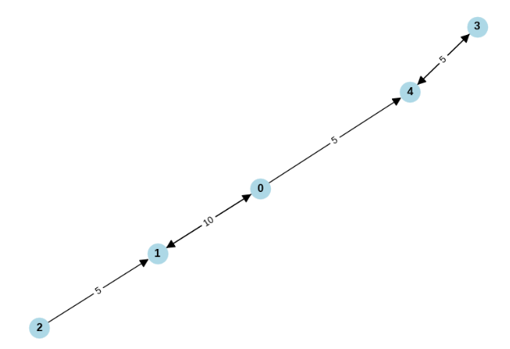

- Consider the graph shown above, by adding extra “dotted” edges to the directed graph above show the Transitive Closure for this graph.

- Bob loves foreign languages and wants to plan his course schedule for the following years. He is interested in nine language courses, with prerequisites as follows:
Language Course | Prerequisite course
LA15 | none
LA16 | LA15
LA22 | none
LA31 | LA15
LA32 | LA16, LA31
LA126 | LA22, LA32
LA127 | LA16
LA141 | LA22, LA16
LA169 | LA32

- Sketch a directed graph to find a sequence of courses that allows Bob to satisfy all the prerequisites.
- If we use the Floyd-Warshall algorithm to compute the transitive closure of the directed graph from part (b), what information about the relationship between the courses does this transitive closure of the graph represent? Give an example using an edge that is added during transitive closure.

Problem 2: Pseudocode Error
Identify the problem(s) in this pseudocode for Floyd Warshall.
define FloydWarshall(graph):
n = number of vertices in the graph
distance = 2D array of size n x n
initialize distance to infinity for all pairs of vertices

for each vertex v:
distance[v][v] = infinity

for each edge (u, v) in graph:
distance[u][v] = weight of edge (u, v)

for i from 1 to n:
for j from 1 to n:
for k from 1 to n:
if distance[i][j] > distance[i][k] + distance[k][j]:
distance[i][j] = distance[i][k] + distance[k][j]

return distance

